**Investigating Chemical Reactions**

Sean Poston

Dr. Ragain

lab performed 2 June 2021

lab submitted 2 June 2021

**Introduction**

The purpose of this lab was to see some different types of chemical reactions that can occur. It also explored how to make these reactions occur. The main part of the lab involved mixing different substances to create gas and it had us test these gasses with different gauges. The chemical reactions that we explored are synthesis, decomposition, single replacement, double replacement, and combustion (Carolina).

Synthesis reactions occur when “two or more reactants combine to make a single new product” (Carolina). Decomposition reactions are the opposite of synthesis reactions. They involve come compound splitting apart into at least two resultants. Single-replacement reactions are the result of one single element replacing a single element in something else. Double-replacement reactions involve two ionic compounds exchanging “ions to produce two new ionic compounds” (Carolina). Finally, combustion reactions are when one element or compound synthesizes with Oxygen to release heat and light, also known as a flame.

This lab was very interesting due to its different types of reactions. Some parts had errors that I didn’t realize until after I completed that part of the experiment. For example, in the precipitation reaction activity, I believe I didn’t have a tight enough seal on the gas tube to properly transmit the CO2 gas to the limewater. This led to no visible reaction occurring. Another error, although I admit I don’t know what I did incorrectly, was in the decomposition. I had no reaction with neither the glowing splint nor the flaming splint. Again, I don’t know where this activity went wrong, but it seems as if it did.

**Photos**

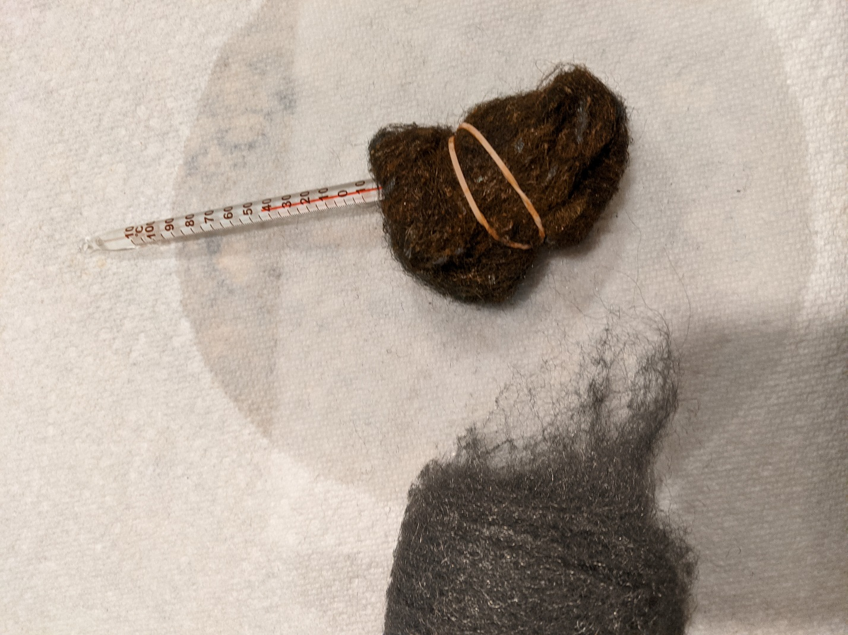

Figure : Steel Wool in Vinegar (right) vs Steel Wool (left)

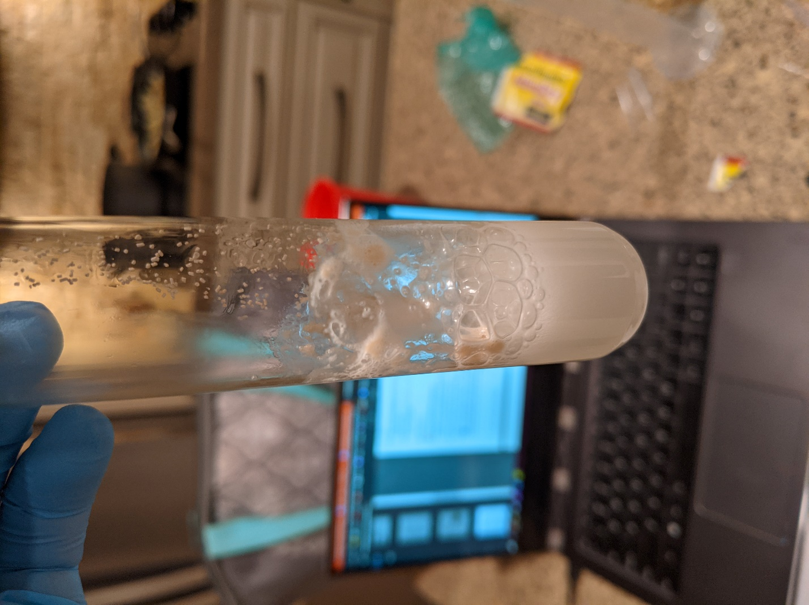

Figure : Yeast and Hydrogen Peroxide

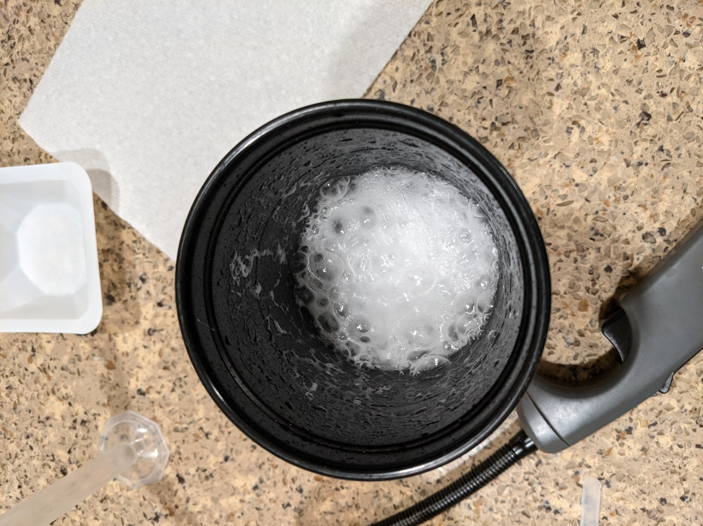

Figure : Vinegar and Baking Soda

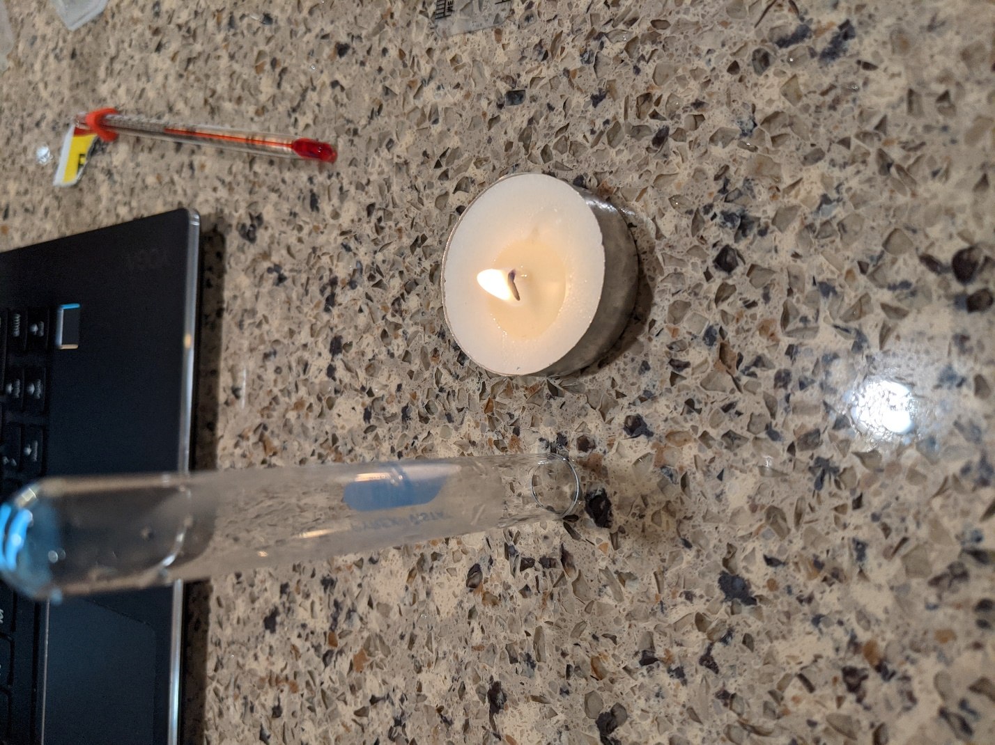

Figure : Candle and Small Glass Test Tube

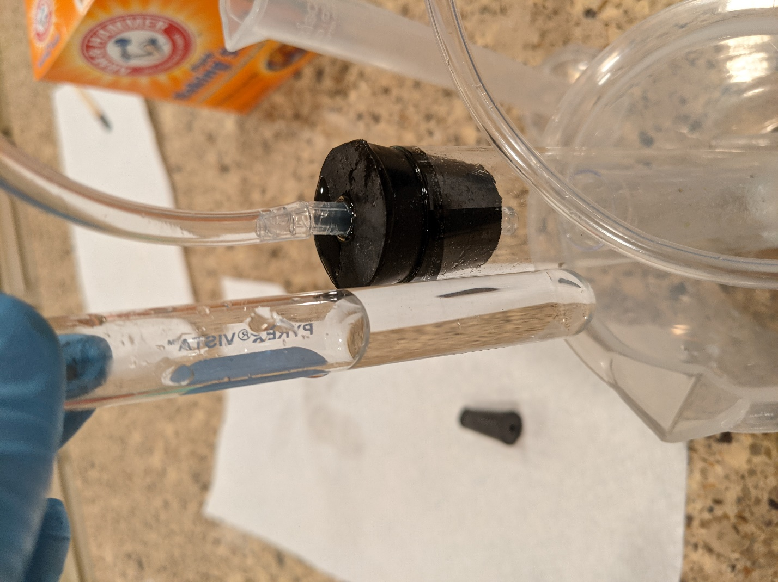

Figure : Limewater (left) and Vinegar/Baking Soda (right)

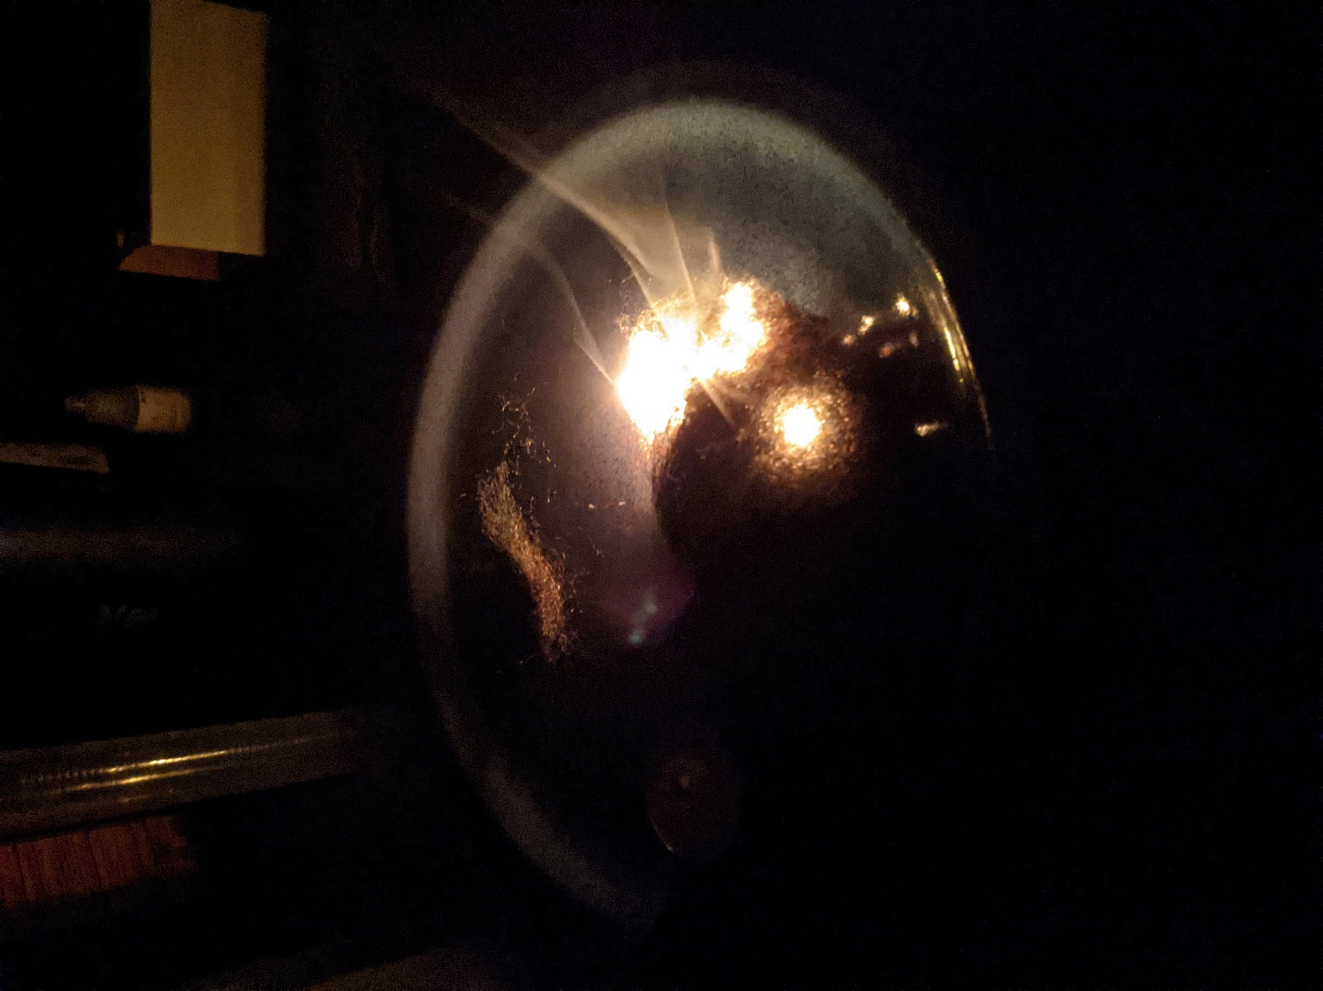

Figure : Steel Wool Burning

**Datasheets**

**Data Table 1**

|  |  |
| --- | --- |
| **Activity** | **Observations and Data** |
| Synthesis reaction | *Vinegar - 20C*  *Steel wool 5 minutes - 38C*  *Steel wool 10 minutes - 45C*  *Steel wool reddened and heated up.* |
| Decomposition reaction | *The hydrogen peroxide started bubbling when the yeast made contact. Eventually, the yeast disappeared and the hydrogen peroxide was slightly murky. I had no reaction with either the Oxygen or Hydrogen gas tests.* |
| Single-replacement reaction | *The Mg begins to aerate. Bubbles start coming out of the stopper. The flaming splint popped and “whistled”, signifying Hydrogen gas.* |
| Double-replacement reaction | *Violently bubbling of the vinegar (barely held in the cup). The glowing splint proved unfruitful, but the flaming splint was snuffed out when it was put into the cup.* |
| Combustion reaction | *The candle was snuffed out.* |
| Precipitation reaction | *The gas transferred to the limewater, but in the end I didn’t see any precipitate. This could be due to a fault in my tubing.* |
| Combustion reaction | The steel wool burned and the flame followed the path of it. |

**Activity 1: Synthesis Reaction**

1. Describe all of the signs that indicated a chemical reaction occurred.

Temperature change, Color change

1. Describe the temperature change that occurred during this reaction. Is heat required or produced during the reaction?

The steel wool and the vinegar heated up quite a bit. It’s produced in the reaction.

1. Describe any other changes that were observed in the steel wool. What reaction might create such a change?

The color turned more brown. This could’ve occurred because the outside layer of the steel wool is being decomposed.

1. Write a balanced equation for the reaction of the steel wool with oxygen. Be sure to include heat energy in the reaction.

4Fe + 3O2 → 2Fe2O3

**Activity 2: Decomposition Reaction**

1. What two gases could potentially be produced from decomposing hydrogen peroxide? Which gas was actually produced? What non-gaseous product formed from the reaction?

Oxygen and Hydrogen gases. I couldn’t tell which gas was produced because my splints didn’t react either way. If I had to guess, I’d say Oxygen because of the balancing. Water was also formed.

1. Write a balanced equation for the decomposition of hydrogen peroxide.

2H2O2 → 2H2O + O2

**Activity 3: Single-Replacement Reaction**

1. What gases could potentially be produced from hydrochloric acid (HCl)? Which gas was actually produced?

Hydrogen and Chlorine gases could be produced. Hydrogen was produced because of the whistling jump that came from the flaming splint.

1. Why did the splint need to be tilted at a 45-degree angle?

To give the most surface area for the flame to ignite the gas.

1. a. Write a balanced equation for the reaction initiated by the burning splint.

b. Classify the reaction initiated by the burning splint.

1. Write a balanced equation for the reaction of magnesium with hydrochloric acid.

**Activity 4: Double-Replacement Reaction**

1. What is the name and molecular formula of the gas formed when baking soda was combined with vinegar, which you identified using flaming and glowing splints?

Carbon Dioxide (hady1123).

1. Write a balanced chemical equation for the double-replacement reaction that occurred when baking soda was combined with vinegar.

1. One of the two products of the reaction of baking soda and vinegar is carbonic acid (H2CO3), which immediately forms water and the gas you identified after exposure to the flaming and glowing splints. Write a balanced equation showing the decomposition of carbonic acid.

**Activity 5: Combustion Reaction**

1. Explain why water appeared on the inside of the glass test tube.

Water was released in the chemical reaction.

1. Write a balanced equation for the combustion reaction.

**Activity 6: Precipitation Reaction**

16. Write a balanced equation for the precipitation reaction. Which product is the precipitate?

Ca(OH)2 + CO2 = C(OH) + CaO

**Conclusion**

The lab taught a lot about the different chemical equations. I ran out of time, so I skipped a lot of the balancing questions in the datasheet section. However, this section is where most of the learning would be done. Overall, the lab was a wonderful experience, and it was one of the most fun ones so far.

**References**

Carolina. Investigating Chemical Reactions Investigation Manual. Accessed June 2, 2021.

Hady1123. Quizlet. <https://quizlet.com/122738524/chem-lab-quiz-types-of-chemical-reactions-and-predicting-products-flash-cards/>

Byjus. What is Calcium Oxide (CaO)?. https://byjus.com/chemistry/calcium-oxide/#:~:text=The%20formula%20for%20lime%20water,lime%20water%20is%20calcium%20hydroxide.

Obligatory bad selfie

